10. Duties of American Citizenship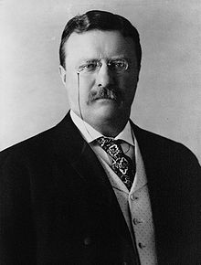
Theodore Roosevelt was the man behind the speech entitled “Duties of American Citizenship” that he presented on January 26, 1883 in Buffalo, New York. As one of the greatest and most effective leaders of the United States, Roosevelt’s speech was borne out of this desire to inspire all Americans to be the best versions of themselves. Given that everyone has different roles to play in their lifetime, Roosevelt reminds every citizen to exhaust everything in their power to be nothing but the best in all of their responsibilities.

